**Assignment 2nd week:**

Problem statement

Setup monitoring for Azure VMs by following the steps below in the Azure Portal

1) Create an Azure VM running Ubuntu 18.04 LTS in the Central US region using SSH for

authentication.

2) Create a Log Analytics Workspace in the Central US region. Ensure that the workspace

has the Log Analytics Contributor Role.

3) Add VM Insights to the workspace created to enable all VMs to send data to

InsightMetrics

4) Install the Dependency Agent on the VM following OS-specific instructions

5) The following link can be used as a reference to perform the given steps:

https://docs.microsoft.com/en-us/azure/azure-monitor/insights/vminsights-overview

**Solution:**

**Creation of Virtual Machine:**

**Steps: Create a VM**

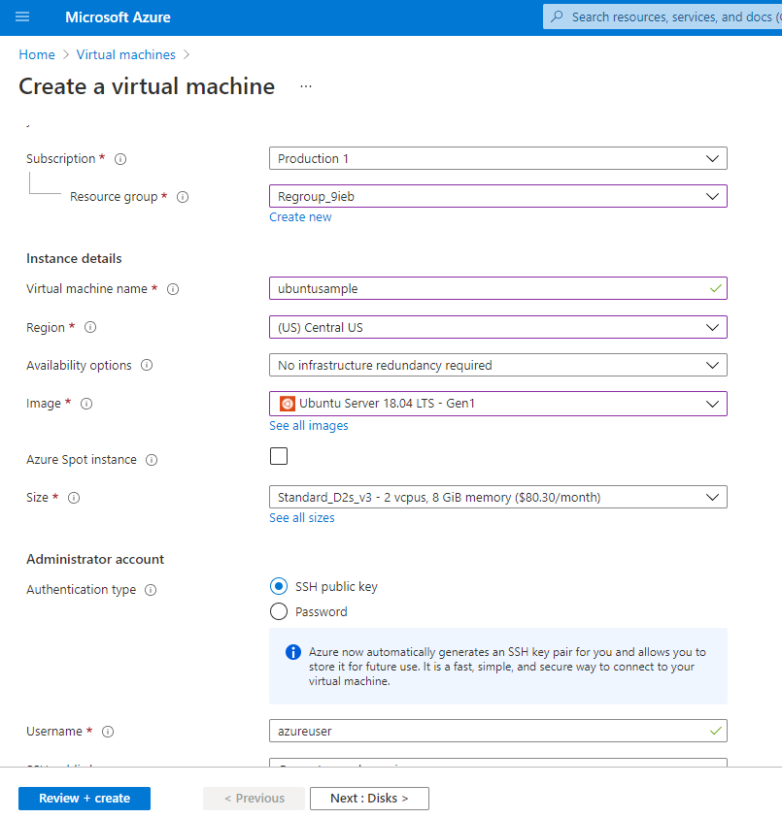

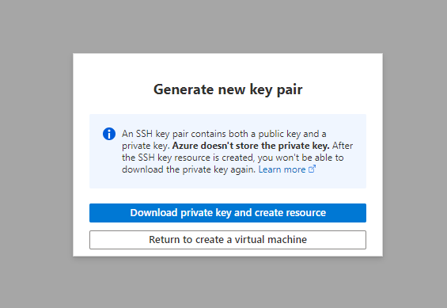

**Deployment In progress:**

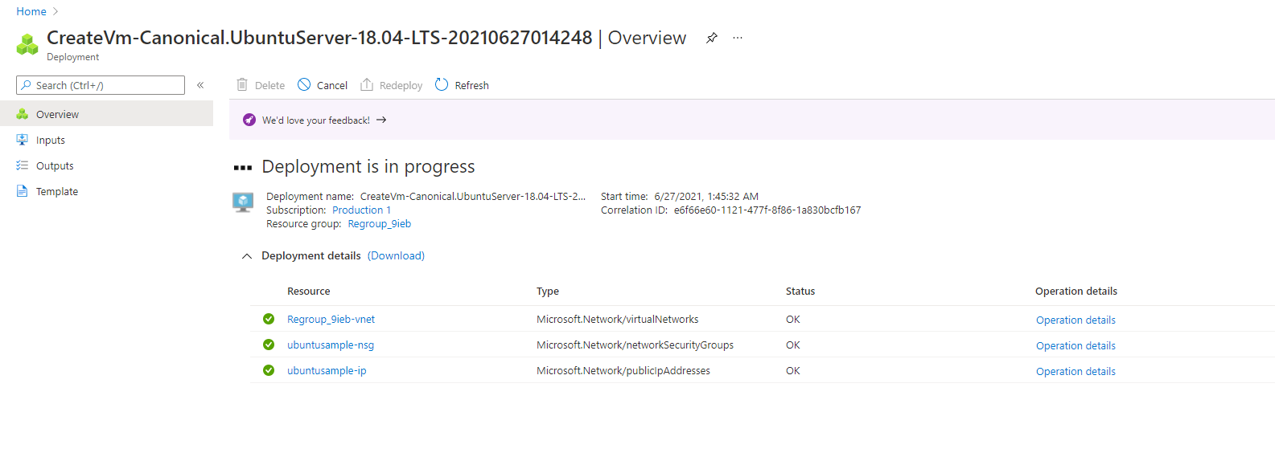

**Deployment completed**

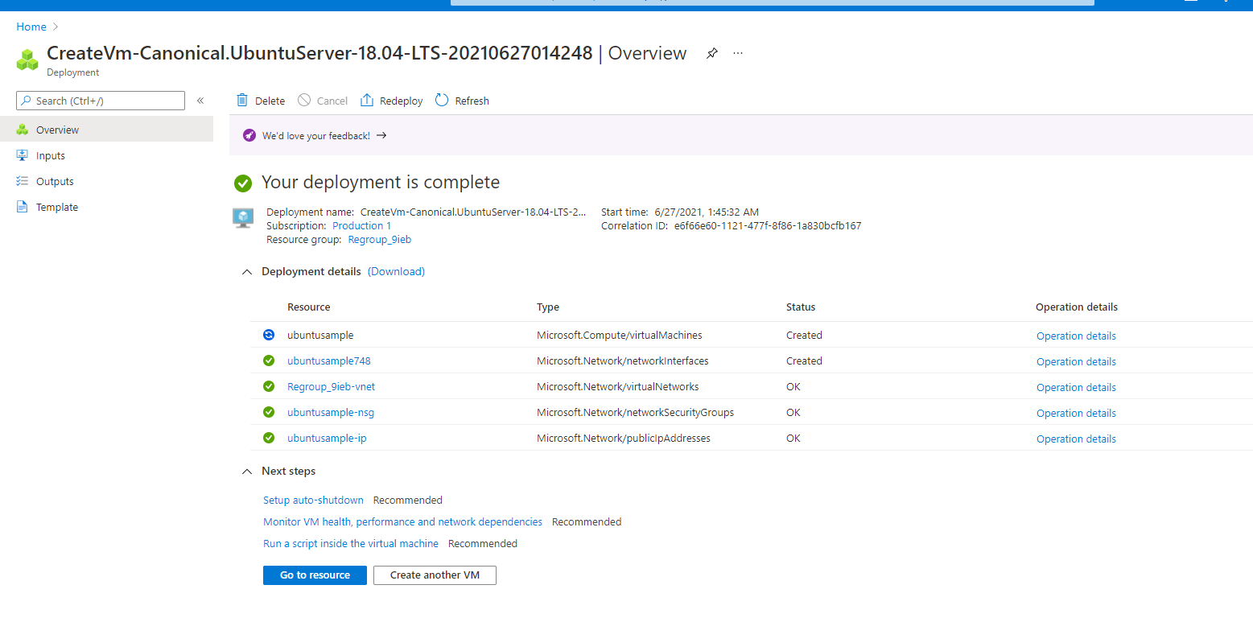

**Creation of Log analytics:**

**Step 1:** Search for Open Log Analytics workspaces

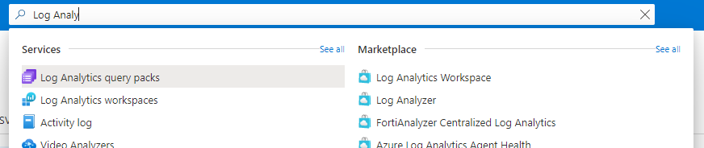

**Step 2: Click on Create and enter details**

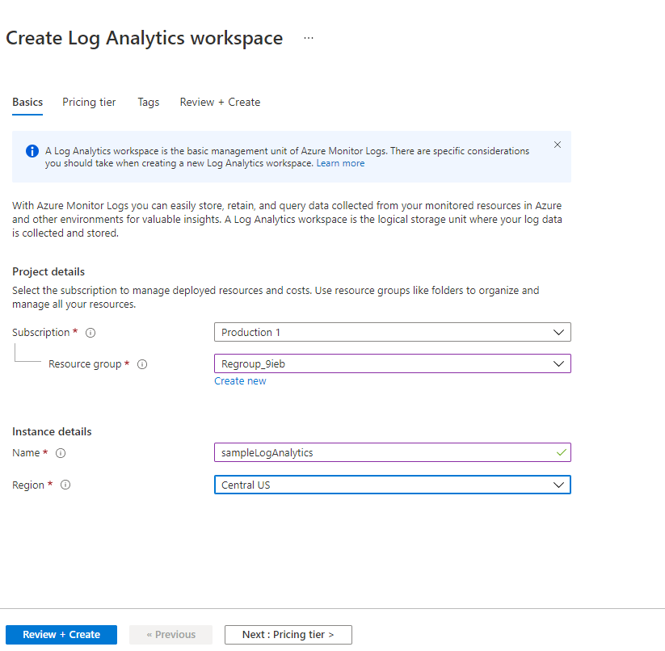

**Step 3: Click on Review and create**

In progress:  
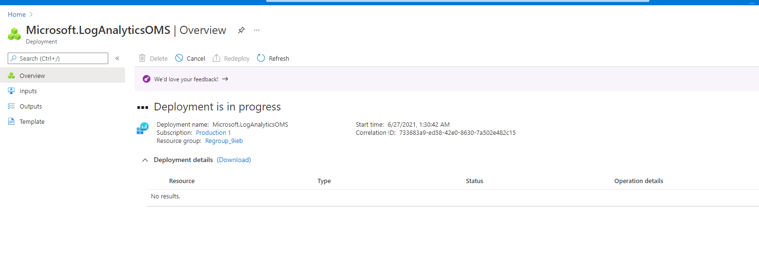

Completed:

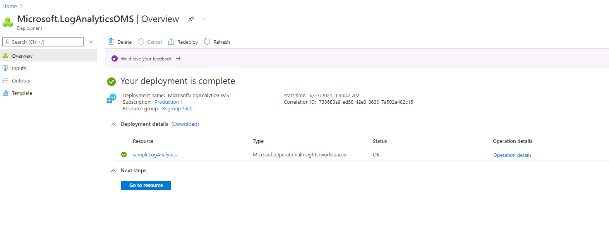

**Step 4: To assign Log Analytics Contributor Role, Click on Access Control (IAM)**

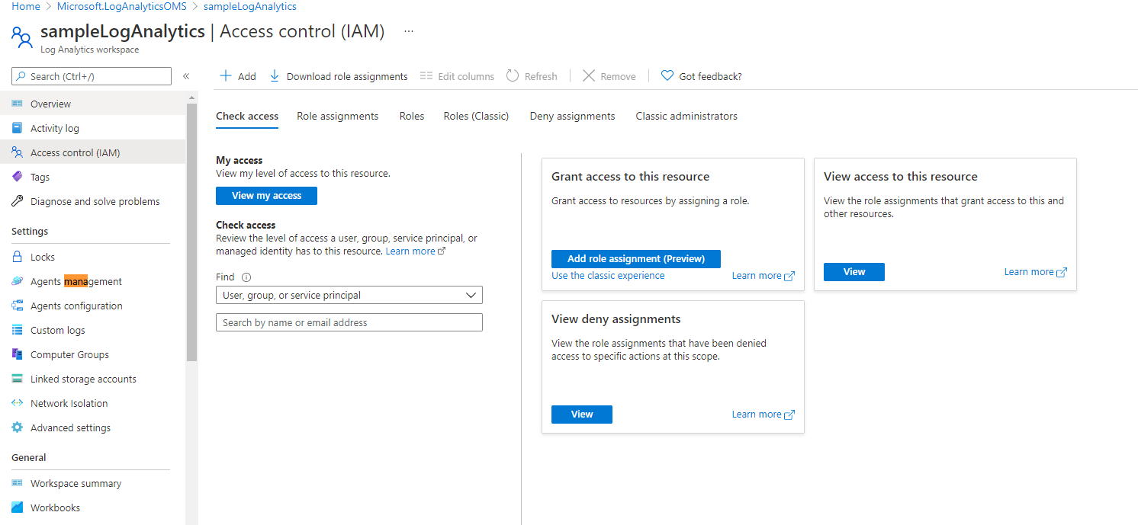

Click on Role assignment and Add new assignment

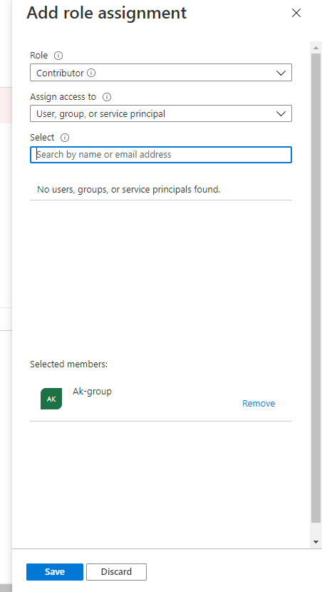

**Creating VM Insights:**

**Steps:**

Go the Virtual Machines option in the Azure Monitor menu, select the Other onboarding options, Click on Configure a workspace

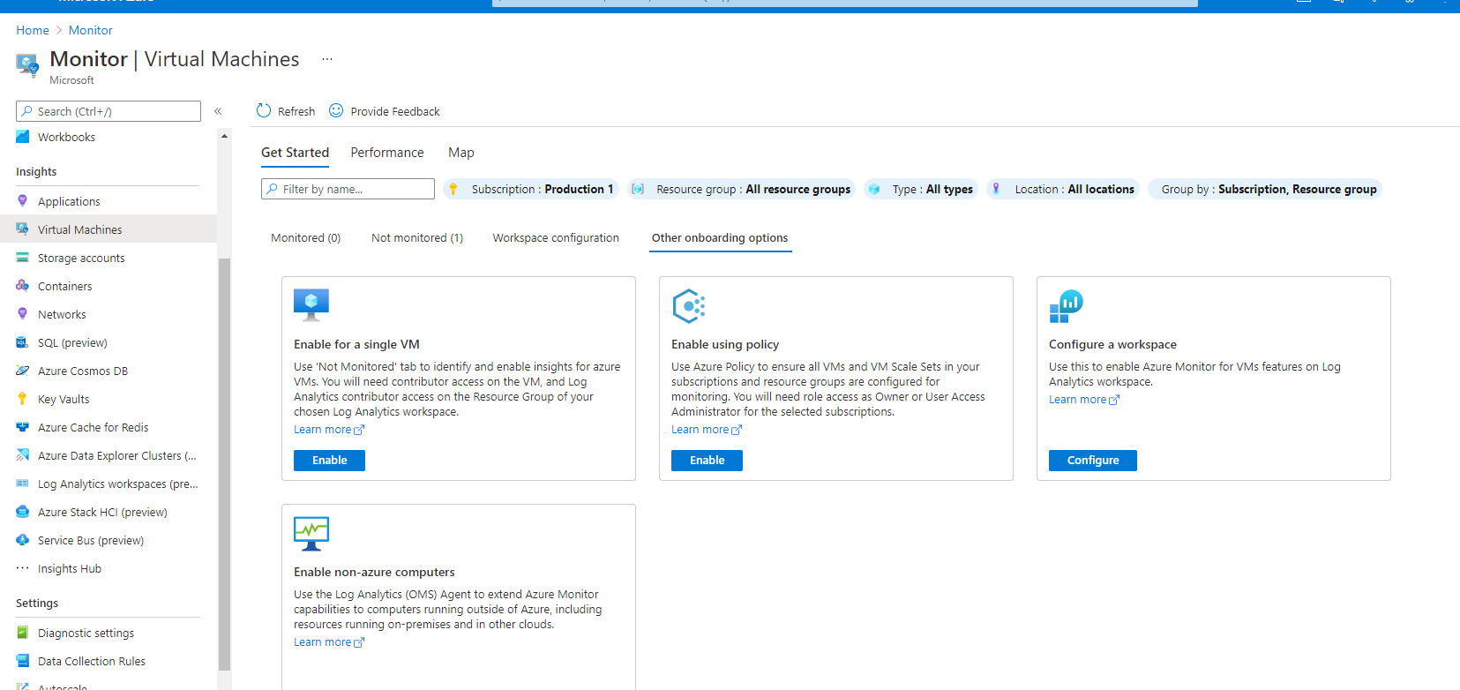

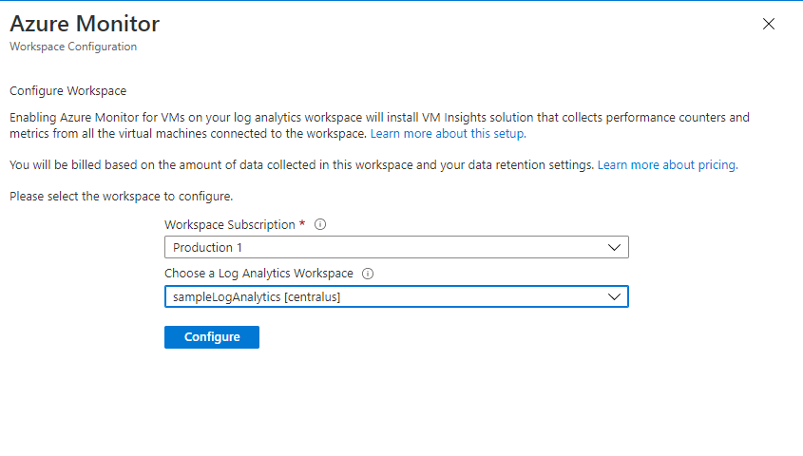

Configured:  
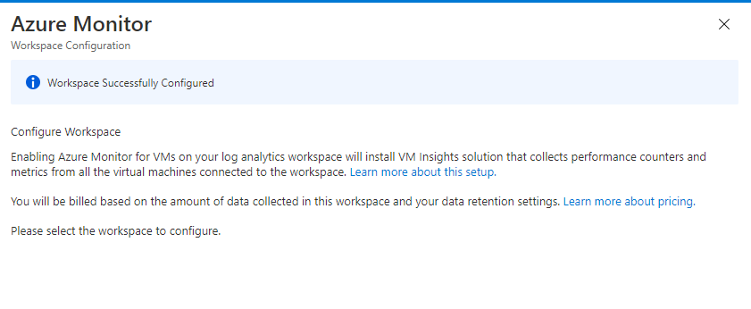

**Analytics Enabled**

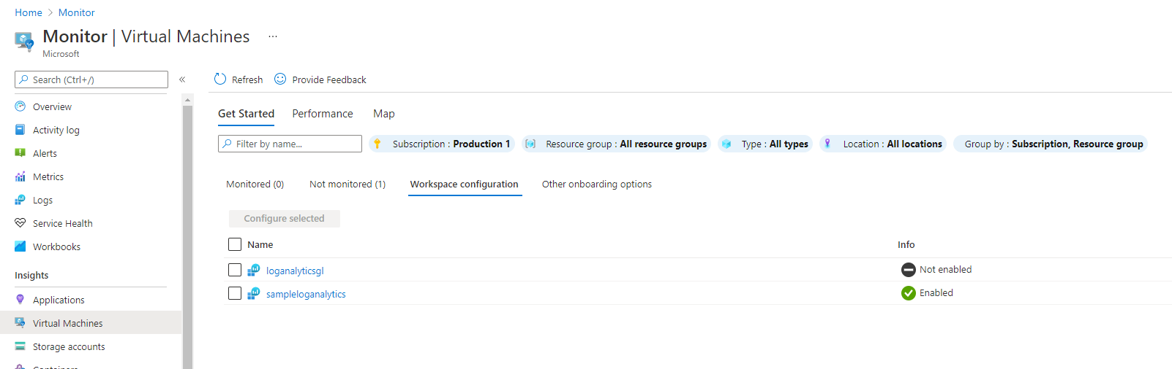

**To add dependency Agents:**

**Click on Agents management**

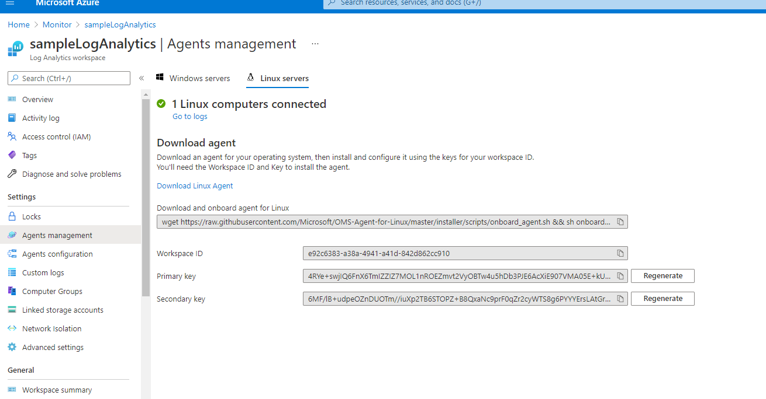

**Linux OS-specific instructions**Go to Agents configuration

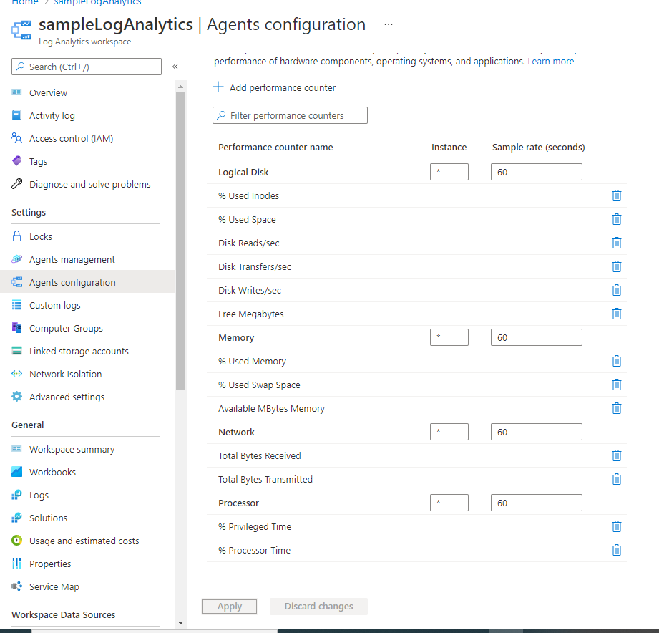

**To check logs:**

* Click on Logs
* Enter Search *
* And run query

